RURAL DEVELOPMENT SOCIETY (RDS)
Home
About us

Our Work
Gallery
Documents
Donors & Partners
Connect With Us
Affiliations
Tribal Association for Fifth Schedule Campaign - TAFSI
Social Action Movement -SAM
Tamil Nadu Voluntary Health Association-TNVHA
Thozhi

Completed projects
Ongoing Projects
Impacts:
Community Leadership
Institution Building
Water & Sanitation
Health
Education
Economic Development
Our Service Area:

Photographs
Media
News
Annual Report 2023-2024
Annual Report 2024-2025
Annual Report 2025-2026
Financial Report 2023-2024
Financial Report 2024-2025
Financial Report 2025-2026

State and Central Govt. Departments
Foreign Donors
Financial Institutions
Individuals
Whats App
Facebook
Instagram
You Tube
Twitter
Linkedin

Who we are?
About RDS
The Need
Evolution
The Team
General Body
Staff Team

Our history
We believe:
Every person deserves to lead a more secure, prosperous, and delightful life. With that vision in mind, Rural Development Society’s mission is to strengthen community led development initiatives to achieve positive social, economic and environmental changes across Dharmapuri district.
Rural Development Society has been working since 1989, to improve the quality of life of the rural communities in Dharmapuri district. As a rural development NGO, established as a Society, RDS has a skilled and dedicated team that create sustainable projects and programme areas: Women Empowerment, Agriculture development, Water Management, Local participation and sustainability, and outreach for Development. These programmes and projects are supported by a skilled staff team that engages in participatory manner, impact assessment and interactive dialogue to determine informed actions to achieve sustainable results.
With the support from donors and partners around the world, RDS’s gross roots programmes and projects and development interventions have already reached people in 3 Taluks across the district, empowering individuals and communities in need to escalate and enhance their own development.
With more than three decades of experience in sustainable rural development, the teams at RDS in three Taluks, so far, across the Dharmapuri district have been on the forefront to design and implement interventions based on collective action, addressing pertinent rural development issues.

RDS ethos and Values:
Our organization’s operating philosophy is based on the principles of loose and tight, meaning in flexible in operations and firm on core values. RDS embraces core values of integrity, excellence, professionalism, optimism, and respect along with the belief that, with appropriate support from civil society organizations and the Government, rural communities will be mobilized to develop their own vision for development and transform their awareness into action.
RDS’s Vision:
Our vision is a rural India where everyone has an equal opportunity to thrive. By putting communities first and deploying innovations in public and private systems we seek to build flourishing localities.
RDS’s Mission:
Our mission is all about transforming villages, sparking innovation, and launching initiatives that make a difference. From day one, we’ve zeroed in on creating sweeping, systemic change, because we believe in impact that’s not just deep but also wide.
Rural Development Society established in 1989, began its journey with a single mission — to improve the lives of the underprivileged. Over the years, we have grown into one of the committed NGOs in Dharmapuri district of Tamil Nadu, dedicated to creating meaningful change through compassionate community service. As a socially driven organization, we work across multiple areas, including community leadership & Institution building, Water and Sanitation, Health, education, women’s empowerment, social justice, Economic development and the uplifting of the poor.
NEEDS:
Understanding the Multi-Faceted Struggles of Stranded India
The people of the bottom thousands of villages live in extreme poverty. Despite good intentions, most development efforts are not sustainable. Life is precarious, leaving many rural Indians vulnerable, dependent and forced to migrate for survival.
The causes -
- Poor education, healthcare and infrastructure
- Social isolation and exclusion
- Weak governance and oversight
- Lack of local leadership
- Fragmented approaches
- Insufficient investment, both public and private.

Evaluation:
Year Milestones
Empowering rural women through group formation, training and socio-economic development supports.
Free Ambulance service for people during emergency
Create awareness on safe drinking Water and environmental hygiene and sanitation
Provide supports to farming communities both financial and technical for Village development.
Training provided for equipping women SHG members on book keeping and maintaining records of the financial transactions in a more simple and efficient manners
Address the health needs of underserved rural areas and formed at village level Health and sanitation committees and Monitoring committees. Creating friendly environment among the health service providers and the rural people through motivational activities.

Achievements at a Glance:
- 7000 rural women have been organized and formed 400 women SHGs in our project area in Dharmapuri district of Tamil Nadu. In women empowerment programmes implemented with NABARD and Tamil Nadu govt’s “Mahalir Thittam” (Tamil Nadu Corporation for Development of Women (TNCDW). RDS have formed SHG’s and linking them with NABARD and nationalized banks and availing subsidies the loans and Economic Activities funds for the past two decades. More than 300 SHGs were linked with banks and mobilize around 50 crore rupees as revolving loan and economic assistance for their economic sustainability and more than ten thousand of rural poor women benefitted through the project. And stopped 50% of migration in the project area among the rural population especially Dalit families.
- RDs has alone some fruitful and effective services with NABARD support it was implemented Village Development Programmes (VDP I & II). along with community participation. RDS’s main activity was to assess and support the concern authorities to fulfill the village basic amnesties like potable drinking water, school infrastructures, renovation of water bodies and children skill etc. with NABARD supports and along with community participation.
- Micro Enterprises Development Programmes since 1284 women have been assisted in setting up family based micro-enterprises by skill training provided.
- Promoting sustainable agricultural practices among the rural farming communities especially women farmers. RDS have trained farmers to follow traditional technologies blended with modern agricultural methods and should use organic manures and to save traditional seeds. Further RDS trained to the farmers to improve our food security through small and minor millets promotion and also provided traditional small and minor millets to cultivate and improve their food security. More than 500 small and marginal farmers benefitted.
- Strengthening of ethnic and Scheduled Tribal communities and their organizations in Tamil Nadu to demand for the implementation of the provisions of 5th schedule for Tribal Self Rule and provide forest lands according to the Forest (Land Rights) Act 2006 have been done for the last 10 years by Tribal Association of Fifth Schedule Campaign (TAFSC) leading by VRDP- NGO based in Salem. RDS is one of the partner NGO in the Network and involving in the Campaign from its inception. The fifth schedule reveals that the Tribal owned land should not be sold to non – Tribes. Keeping in mind those Tribal Rights, RDS made a base line survey among 219 tribal families and 15 conducted village level meetings. RDS organized several meetings among the tribal communities on Rights of Tribal, Rights to use Non – Timber Forest products and sustainable Tribal livelihood sources etc. were taught in Pappireddipatti Taluk of Dharmapuri district.
- To reduce the rate of school dropouts in the rural areas, RDS has formed a committee under the Neighborhood Community Network – NCN in our Project villages. Through that committee School enrolment campaign, education awareness and parents counseling etc. were done in the same villages. Booster that the school students were organized and brought them to the government higher secondary schools to see the effective functions of “children’s parliament”. After that exposure the students have formed that child ‘s parliaments structure in the Higher Secondary and High schools in the Kadathur and Morappur Blocks by which the school students have acquired knowledge.
- 25 SC/ST school drop-out children were educated through SSA programme implemented by our organization with the support of Department of Education in 2012.
- 40 Dalit Panchayat leaders were trained about Panchayat Raj Institutions
- In rural health development RDS worked with National Rural Health Mission (NRHM) under Community Action for Health which assures quality Govt. health services in Karimangalam and Harur Blocks from 2010 to 2012. To make better health in the rural areas, RDS formed Rural Health committees (RHC) and created awareness on activities. The people of rural areas have gained knowledge on the layers of health department and its services, government health schemes and provisions, and alternatives to activate and avail health services in the said Blocks in the district and formed Rural Health Committees consists 150 members.
- RDS conducted monthly support group meetings to support nutrition’s food, cloths, medicines, education and economic assistance to the children of People Living with HIV/AIDS(PLHA). Through the programmes, RDS found that 12 PLHAs in its project areas and provided support services like financial supports (Rs.10000/- per PLHA) and Public Distribution Cards (PDS) and Old Age Pensions (OAP) to PLHAs through the Special Fund of District Collector. RDS also arranged various stakeholders meeting and mobilized various supports like medicines, economic assistance, nutritional food supply and the like to PLHAs.
- RDS provided, Ambulance services through Health System Project supported by the Department of Health & Family Welfare, Tamil Nadu Government.
- Making sound India is possible when ensured participation, involvement, ownership attitude in Individual House Hold Latrine (IIHL) planning, execution and monitoring both by the beneficiaries and officials. Need and importance of IHHL construction and usage should be insisted to the beneficiaries by the Swatch Bharath Misson team, and then only the goal of SBM is achieved. Keeping in mind this concept, with the support of Public Affairs Centre (PAC), Bangalore RDS made a CSC exercise in selected Village Panchayats and found that the reality of IHHL constriction, usage of IHHL, awareness building, action taken by the officials etc., were exposed openly-which has led to effective result for future course. that CSC exercise made a clarity among both the beneficiaries and SBM officials. It was completed in 2016.

Globally, 1 out of every 3 blind people lives in India. India has the highest level of blindness in the world with 15 million blind people, cataract being the primary cause. Blindness is a cause & an outcome of poverty. The WHO estimates that between 2010 to2020 the cumulative impact of blindness and visual impairment in India is $162 billion. The Indian districts with lower levels of social, economic, education and health indicators have the highest incidence of blindness. People with no and low vision are at a significant disadvantage. They suffer from poverty, malnutrition, lack of education opportunities and social isolation. This in turn affects their families and ultimately the community at large. RDS believe that no one should suffer from blindness because they cannot afford the cost of treatment and it focuses on reducing preventable blindness by providing free eye screening camps, free spectacles and hospital referrals to those who need further eye care intervention. RDS organized free Eye screening camps frequently since 2014 among the rural people including school children in its project villages with support of Good Samarian Hospital at Matrapalli in Thirupaththur district. Mr. R Dharmalingam, Director of RDS coordinated the eye-screening camps.
- Stopped 50% of migration in the project area among the rural population especially Dalit families.
- RDS formed FPO named “Cattle Breeder Farmer Producer’s Company Limited” with the support of NABARD in Kadathur Block. In total 1000 cattle breeders and farmers are become shareholders of the Company. For their livelihood promotional activity, RDS organized Livelihood and Enterprise Development Programme with the support and supervision of NABARD. 150 women farmers benefited through the programme.
- To find out the Status drinking water, RDS has taken samples of water numbering more than one lakh water samples in the entire Dharmapuri district with the technical and financial support of TWAD Board. The taken water samples had been sent to the TWAD Board Lab for testing and to find out the level of salty, salinity and fluoride etc. Since 2010, RDS involving in Water Testing Project in Palacodu Taluk in Dharmapuri district with the financial support of Tamil Nadu Water and Drainage Board, Chennai.
- RDS achieved many programmes likely for environmental development joint hands with Govt. of India in National Environmental Awareness Campaign (NEAC) for last several years through CPR Foundation, Chennai and sensitized the issue of global warming /climate change mitigation and to involve the community in tree plantation on their own lands and common community lands, continued till date for creating environmental awareness with the participation of SHGs women, school children and common public. including climate change and tree planting activities in schools and rural villages.

The Sustainable Development Goals (SDGs), otherwise known as the Global Goals, are the universal call to actions to end poverty, protect the planet and ensure that all people enjoy peace and prosperity. Rural Development Society (RDS) Projects and Programme serves 10 of the 17 Sustainable Development Goals set by United Nations Development Programme for 2030
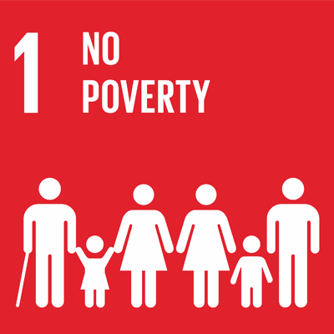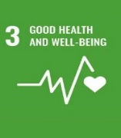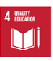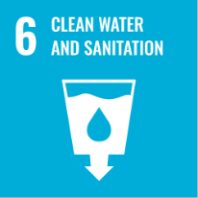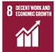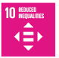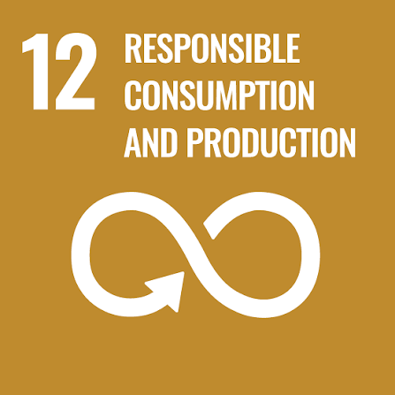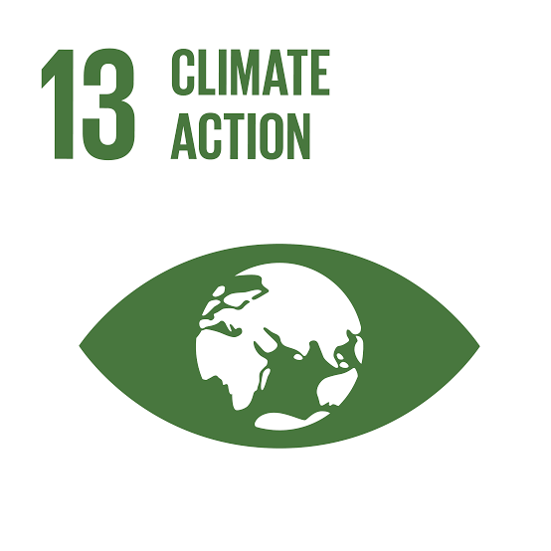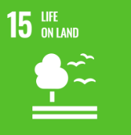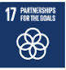

Certifications
TRANSFERENCY IS AT THE HEART OF RURAL DEVELOPMENT SOCIETY
Rural Development Society (RDS) is a non-profit organization, registered as Rural Development Society under Tamil Nadu Societies Registration Act, 1975.
- RDS is registered for undertaking Memorandum of Association (MOA) and Articles of Association (AOA) with the Office of Registrar of Societies (Under Tamil Nadu Societies Registration Act, 1975). The MOA and AOA includes our purpose of incorporation and guidelines for operation; vide
No: 128/1989 dated 16-10-1989 Download
- PAN (Permanent Account Number) No: AABAR3777P Dated: 16/10/1989
- TAN (Tax Deduction Account Number) No: CHER20700B
- GST No: 33AABAR3777PIZY
- RDS is registered for 12A with the Office of Registrar of Societies (Under Tamil Nadu Societies Registration Act). 12A registration is granted by the Income Tax Department to non-profit organisations for exemption of income tax payments. AABAR3777PF20215 Download
- RDS is registered for 80G with the Office of Registrar of Societies (Under Tamil Nadu Societies Registration Act). An 80-G Certification is a document issued by the Income Tax Department to certain NGOs to allow donors to avail of tax deductions. AABAR3777PE20043Download
- RDS is registered for undertaking with the office of Registrar of Societies (Under Tamil Nadu Societies Registration Act). Under section 6(1) of the Foreign Contribution Regulation Act, 2010, an FCRA Certificate is required for Societies, Trusts, Sec 8 Companies to receive donations from foreign sources FCRA No: 075870073 (Valid till xxxth xxxx (month) 2028), Download
- RDS is registered for undertaking CSR activities with the office of Registrar of Societies (Under Tamil Nadu Societies Registration Act). A CSR1 Certificate is required for NGOs to get funding from Corporates and undertake CSR activities. No: CSR00083308 Download
- RDS has appointed a Board Members. The updated register of Board Members as FY2026-2027 is disclosed here. (Click here to view the Board Members)
- RDS is registered and recognized by the Government on NGO Darpan, on online portal launched by the Government of India for the registration and management of NGOs in India. No: TN/2017/0155538

Contact Us

You Can Reach us on: Google Map
Rural Development Society (RDS)
65-B, EVR Periyar Street,
Kadathur,
Pappireddipatti Tk, Dharmapuri
Tamil Nadu. PIN: 635 303.
For all general enquiries:
Use contact Form here:
Please fill out the form below and we will get back to you as soon as possible:
First Name:____________________________ Last Name:____________
Email:________________________________ Subject: ______________
Leave as a message……….

Submit

Donate
Events

Site Map

